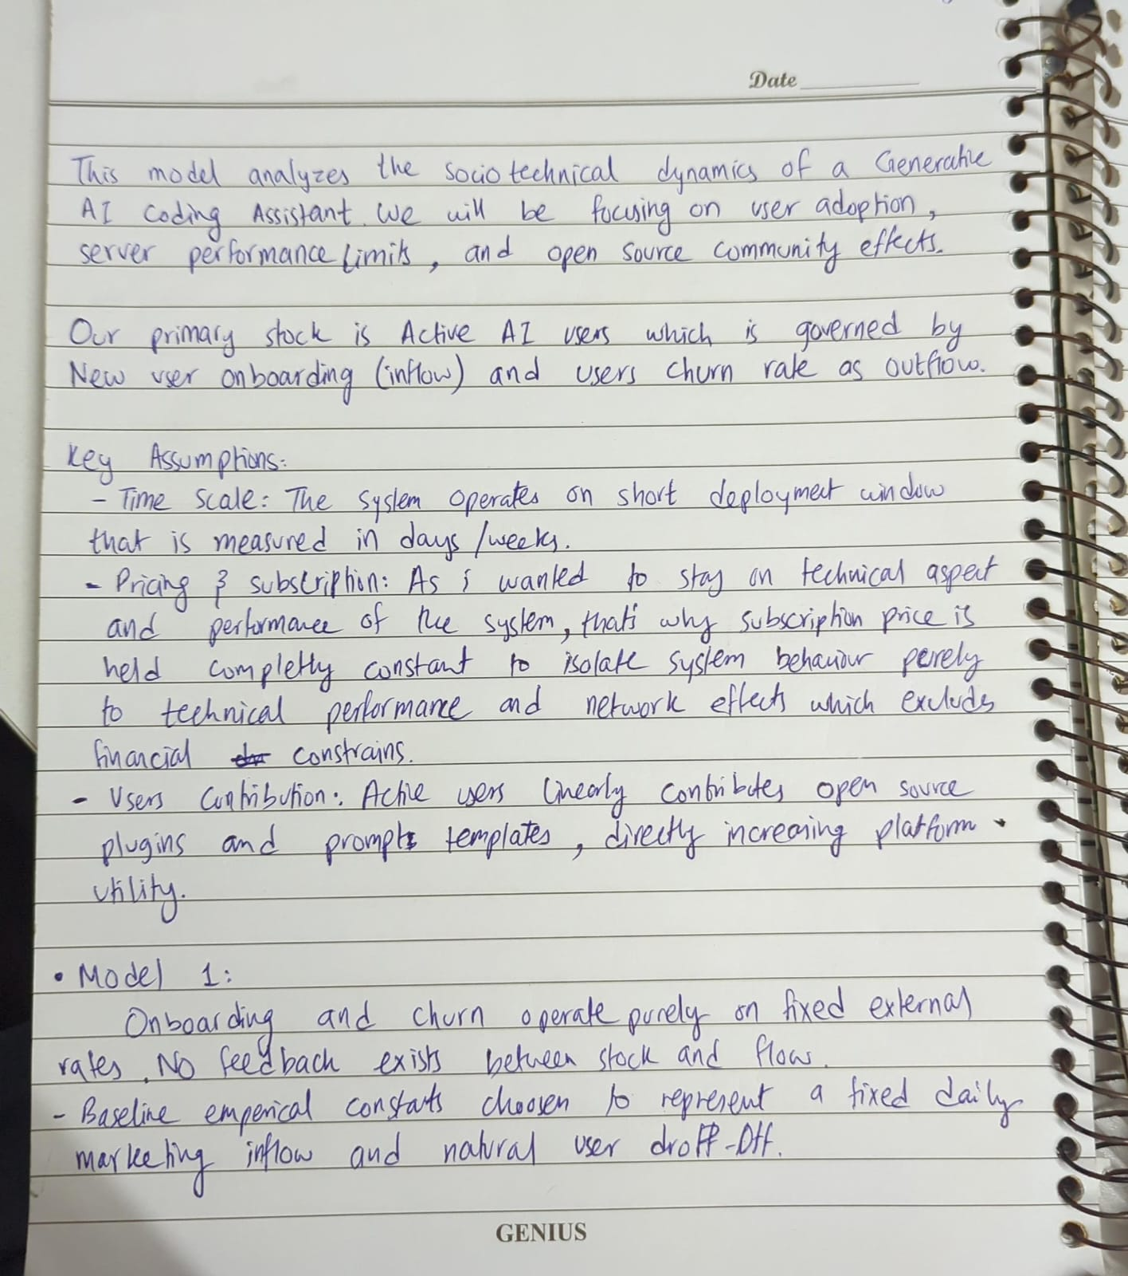

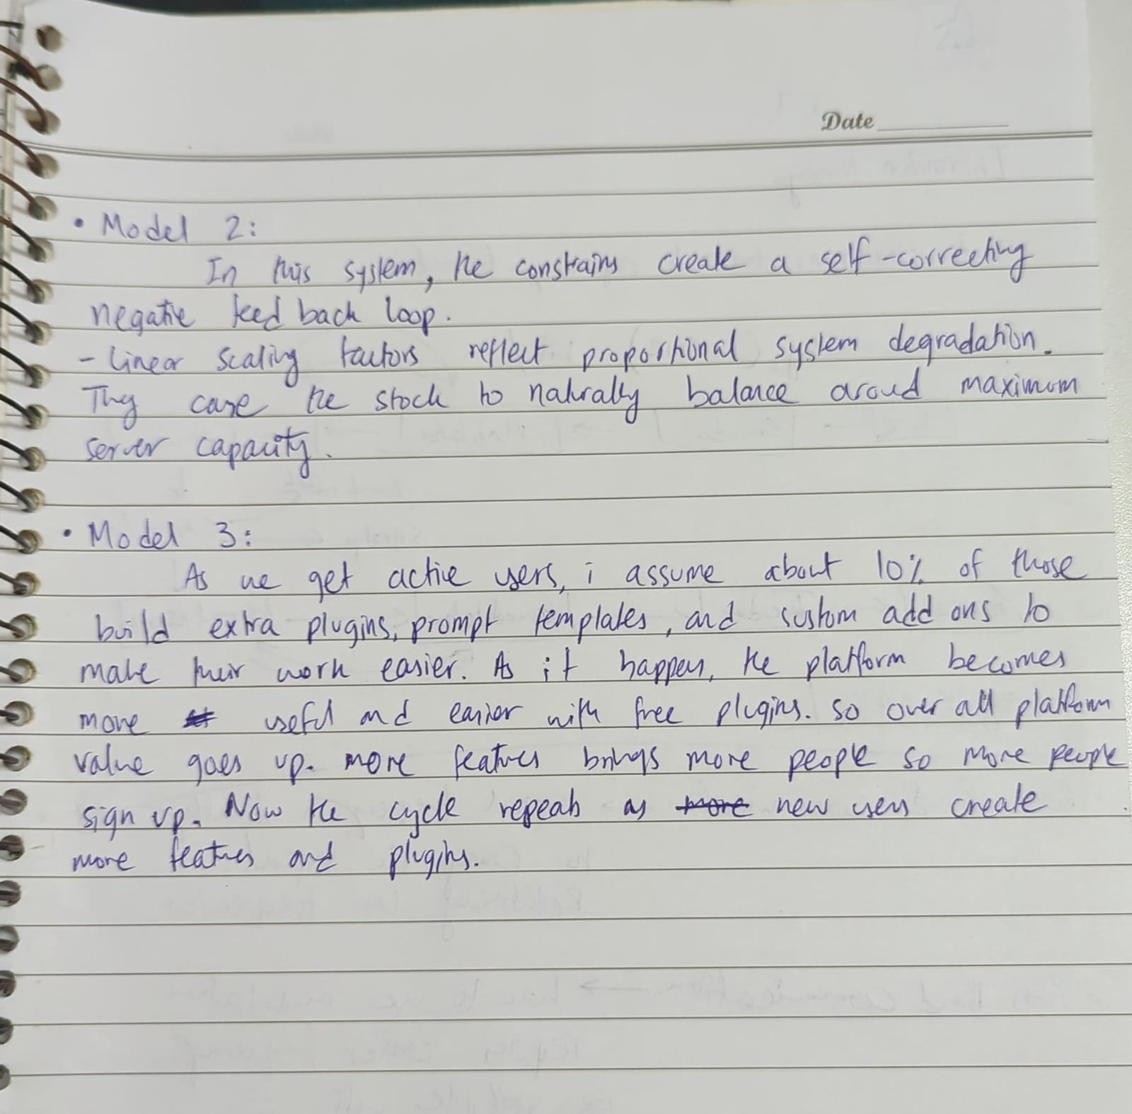

Stock flow diagram without any feedback loops:
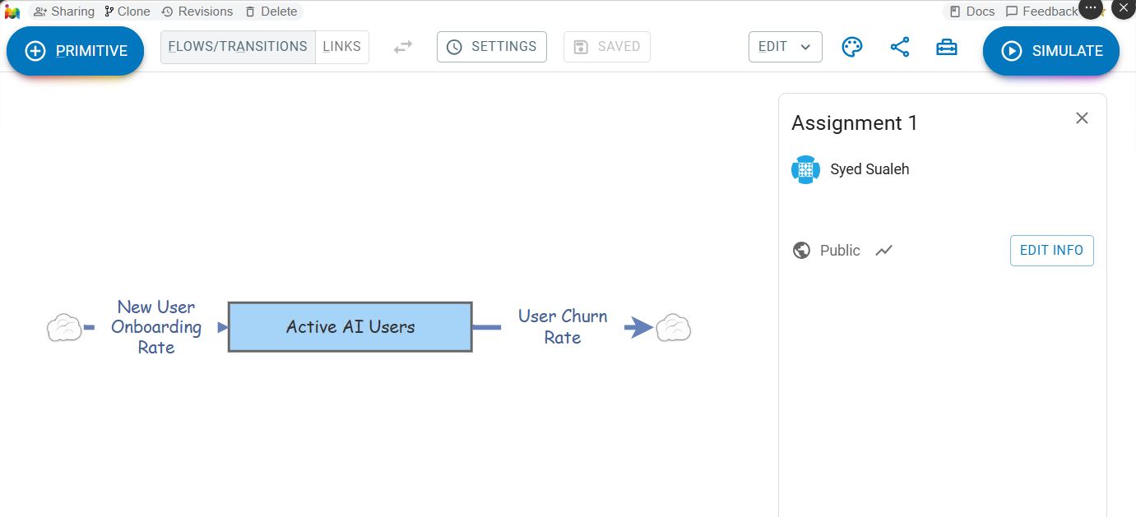
Inflow Rate 50 users/day, Outflow rate 20 users/day
Simulation Results:
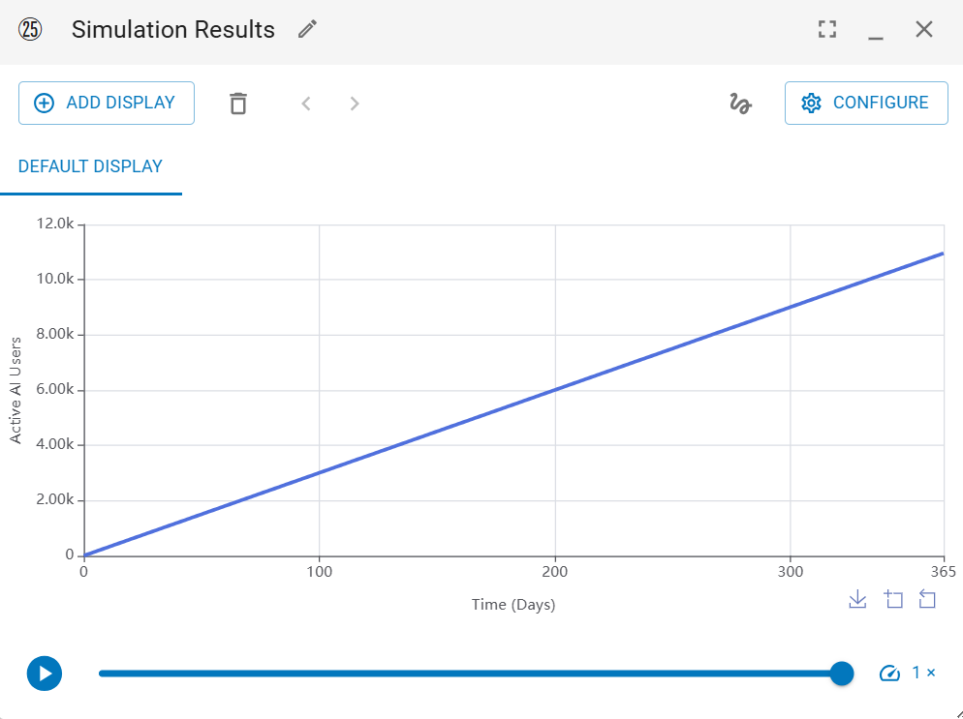
Linear growth. Inflow > outflow, the stock increases in a straight diagonal line (Net = +30 users/day).

Stock-and-flow diagram with only balancing loops:

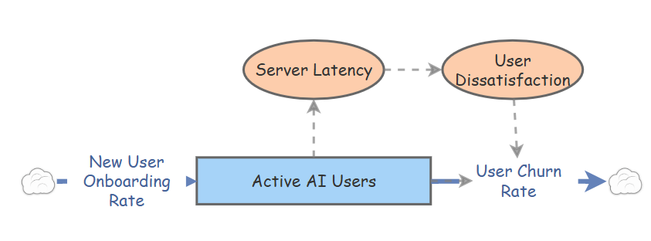
Server latency=[Active AI Users]*0.08
User dissatisfaction=[Server Latency]*0.2
Churn rate=[Active AI Users]*0.02+[User Dissatisfaction]*2
Onboarding rate= 100 users/day

Simulation Results:
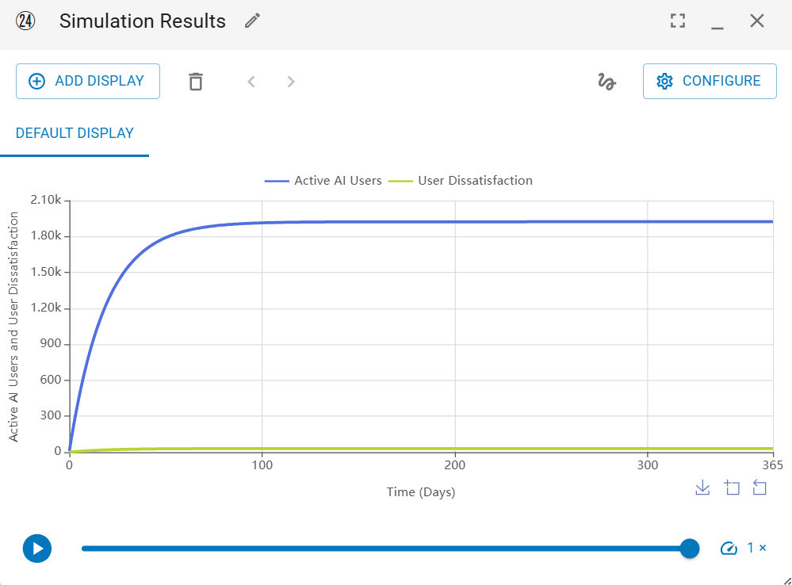
The active user count follows an curve growth path, rapidly increasing before leveling off and becoming straight near 1,900; server latency increases dissatisfaction and churn.
Stock-and-flow diagram with only reinforcing loops.
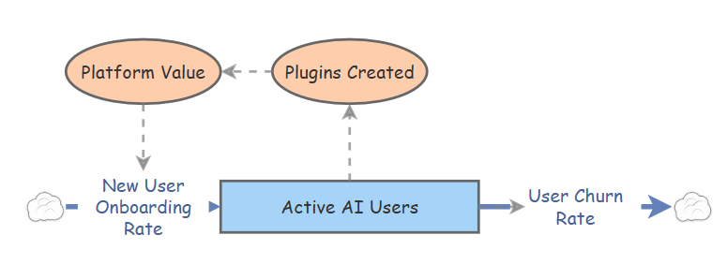
Churn rate=10
Initial value of active ai users=10
Plugins=[Active AI Users]*0.1
Platform value=[Plugins Created]*0.5
New onboarding rate=10+([Platform Value]*0.2)
Simulation results:
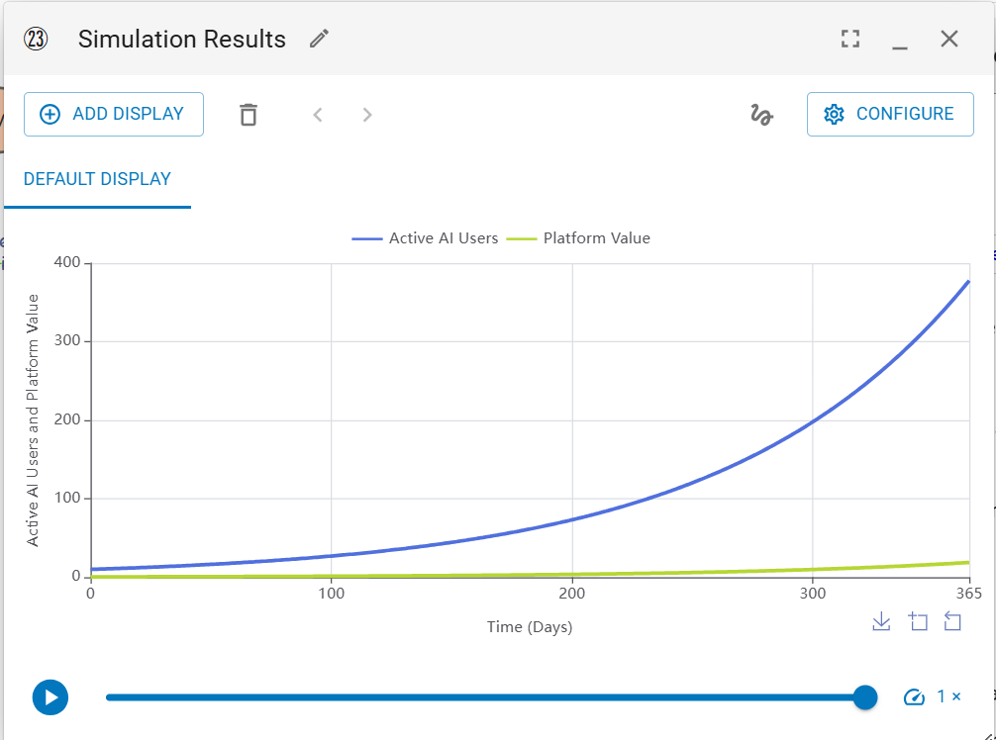
The active user count follows an accelerating upward exponential curve effected by community plugin creation and compounding platform value.
Submission by:
Syed Sualeh Abbas- 10303
D-3

